
CSA15 Cloud Computing and Big Data Analytics
CO1 AT2 - Digital Concept Map and Service Model Matrix
Individual Student Submission Template

Student and Faculty Details
Student Name | P. Sujith Reddy | Register Number | 192525422
Class / Section |  | Slot | B
Course Code | CSA1512 | Course Title | Cloud computing and big data analystic
Capstone Title | Safe Walk Cloud Route Intelligence Using Crowd Reports and Risk Heatmaps
Submission Date
Faculty Name | Dr. C. Rajesh Babu | Employee ID
Department | AIML

Assessment Brief
Course Outcome | CO1 - Explain the evolution, architecture, characteristics, service models, and emerging paradigms of cloud computing.
Assessment Type | Individual concept mapping, service-model responsibility analysis, and capstone-cloud interpretation.
Assessment Focus | Each map must show key nodes, link labels, relationship meaning, and a logical hierarchy. The response must connect cloud fundamentals to the student's own perception of the capstone title.
Submission Mode | Editable DOCX + exported diagram evidence + GitHub repository link submitted in Google Classroom.
Permitted Tools | draw.io / diagrams.net, Lucidchart, Miro, Canva,  PowerPoint, Google Drawings, or equivalent diagramming tool.
Individual Rule | Every student must submit their own concept map, matrix, capstone-cloud mapping, and reflection. The capstone title may be shared by a team, but the assessment answer must not be common.
Total Marks | 100 marks

Code of Conduct and Student Assurance
Academic Integrity Statement
This assessment must be completed individually. Students may discuss the capstone domain with their team, but the concept map, service model matrix, explanations, GitHub evidence, and reflection submitted here must be individually prepared.
 | Student Assurance |  | I confirm that this submission represents my own understanding of CO1 concepts and my individual interpretation of the selected capstone title.
 | Tool Use |  | I have used digital tools only for diagram preparation, organization, and presentation. I have not copied another student's diagram, matrix, or explanation.
 | Evidence |  | I have uploaded the required files to my GitHub repository and submitted the repository link / evidence link through Google Classroom.
Student Signature |  | P. Sujith Reddy
Date |  | 20/07/26

Procedure for Preparing the Digital Concept Map
Use the following procedure to prepare the diagram and upload evidence. Students who already know another diagramming tool may use it, but the exported evidence and source file must still be submitted.
- Open https://app.diagrams.net/ or the desktop version of draw.io / diagrams.net.
- Choose Device, Google Drive, or OneDrive as the save location according to availability.
- Create a blank diagram and name the file as CSA15_CO1_AT2_RegisterNumber_Concept_Map.drawio.
- Place the capstone title at the center or as a clearly visible anchor node.
- Add major cloud nodes: cloud definition, cloud evolution, cloud architecture, service models, deployment models, virtualization, web services, SOAP, REST, APIs, elasticity, scalability, resource pooling, measured service, and emerging paradigms.
- Connect nodes with labeled arrows such as uses, depends on, enables, scales through, communicates through, belongs to, supports, provides, consumes, or controls.
- Use colors meaningfully: one color for service models, one for cloud characteristics, one for API/web-service concepts, and one for capstone-specific elements.
- Export the final diagram as PNG or PDF. Keep the editable .drawio source file also.
- Paste the exported diagram image or screenshot in this DOCX under Task 1.
- Upload the DOCX, exported PNG/PDF, and .drawio file to GitHub, then submit the GitHub link in Google Classroom.

GitHub Submission Procedure
Step | Required Action | Expected Evidence
1 | Create or use your individual GitHub account. | GitHub profile link.
2 | Create a repository named  CSA15-CO-Assessments-RegisterNum  ber or use the repository instructed by faculty. | Repository URL.
3 | Create a folder named CO1_AT2 inside the repository. | Folder visible in repository.
4 | Upload this completed DOCX, exported diagram PNG/PDF, and editable .drawio source file. | At least three evidence files uploaded.
5 | Add a short README.md explaining the capstone title and files submitted. | README visible in the AT2 folder.
6 | Submit the GitHub folder link in Google Classroom. | GCR submission with repository/folder link.

Assessment Questions and Student Response Sections
Important
The capstone project may be developed by a team, but every response below must be written from the individual student's own perspective. Do not submit a common team answer.

Task 1 - Digital Cloud Concept Map
Create one integrated digital concept map for CO1. The map must show key nodes, link labels, relationship meaning, and a logical hierarchy. It must also connect the concepts to your selected capstone title from your individual perspective.
Mandatory Concept Group | Minimum Concepts / Nodes to Include
Cloud Fundamentals | Definition, characteristics, benefits, limitations, on-demand access, measured service.
Cloud Evolution and Drivers | Hardware evolution, internet software evolution, distributed systems, cost economics, mobility, remote access, big data growth.
Architecture and Deployment | Front-end, back-end, network layer, data center, management software, public/private/hybrid/community cloud.
Service Models and Responsibility | IaaS, PaaS, SaaS, XaaS, provider responsibility, user responsibility, shared responsibility.
Virtualization and Web/API Layer | Virtual machine, hypervisor, abstraction, resource pooling, multi-tenancy, web services, SOAP, REST, API request/response.
Capstone Connection | Your capstone users, app/module, cloud backend, database/storage, dashboard/analytics, scalability and elasticity idea.
Paste exported concept map image / screenshot here. Resize neatly within this white space.

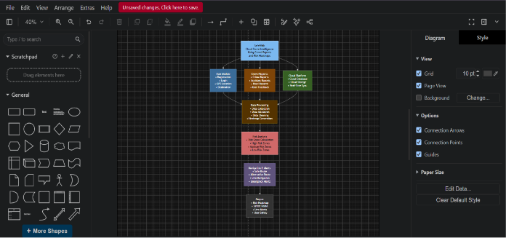

Brief explanation of your concept map: explain the most important nodes, link labels, hierarchy, and capstone connection.
This concept map illustrates how cloud computing technologies support the SafeWalk application. The mobile application communicates with the cloud backend through REST APIs. User reports and GPS locations are securely stored in cloud databases. Analytics services generate dynamic risk heatmaps from crowd-reported incidents, allowing users to receive safer route recommendations. Cloud characteristics such as scalability, elasticity, resource pooling, and on-demand services ensure the application performs efficiently even during high traffic and emergency situations.

Task 2 - Service Model Matrix
Complete the matrices by making technical decisions for your capstone project. Select only the rows that are relevant to your capstone design. If a row is not used, write a short technical reason instead of leaving it blank.
Your answer should show how responsibility shifts between cloud provider and student development team, and how the chosen services support the capstone workflow, API design, storage, security, scalability, and evidence submission.
Task 2A - Service Model Responsibility Matrix
Service Model | Capstone Role / Module | Provider  Responsibility | Student  Responsibility | Evidence to Submit
IaaS | Virtual Servers | Maintain VMs, Storage, Networking | Configure server and deploy backend | VM Screenshot
PaaS | Backend API | Runtime, Database, Auto Scaling | Develop REST APIs | API Code
SaaS | Authentication | User Login Service | Integrate Authentication | Login Screen
XaaS / Specialized Service | Maps API & Notifications | Route Maps, SMS, Push Notifications | API Integration | Working Demo
Task 2B - Capstone Cloud Service Decision Matrix
Cloud Layer / Function | Selected Tool or Service | Data / Resource Handled | API or Integration Path | Security / Scaling Note
Client access and UI | Android App | User Input | REST API | HTTPS
API / backend logic | Node.js / Spring Boot | Business Logic | REST | Auto Scaling
Authentication and identity | Firebase Authentication | User Accounts | Firebase API | Secure Login
Database / structured records | Firebase Firestore | Reports, Locations | Firestore SDK | Encrypted Storage
File / object storage | Firebase Storage | Images | Storage API | Secure Access
Monitoring / logs / usage metrics | Firebase Analytics | Logs | Analytics SDK | Performance Monitoring
Analytics / reporting output | Power BI / Firebase Analytics | Heatmaps | Dashboard API | Scalable Reporting
Technical
justification: Explain why the selected cloud service pattern fits your capstone project's users, data, API flow, scalability, and security needs.

Task 3 - Capstone Cloud Flow Mapping
Firebase provides scalable cloud services suitable for a real-time safety application. Firestore stores incident reports with low latency, Firebase Authentication secures user accounts, and Firebase Storage manages uploaded images. REST APIs connect the mobile application with cloud services. Cloud scalability ensures uninterrupted service during peak usage, while analytics generate dynamic risk heatmaps for safer route recommendations.
Study the sample architecture-flow template below. Redraw it in draw.io / diagrams.net using your own capstone architecture. Replace every generic label with your actual user role, screen, API endpoint, backend logic, cloud storage, analytics output, security control, and scalability or elasticity decision.
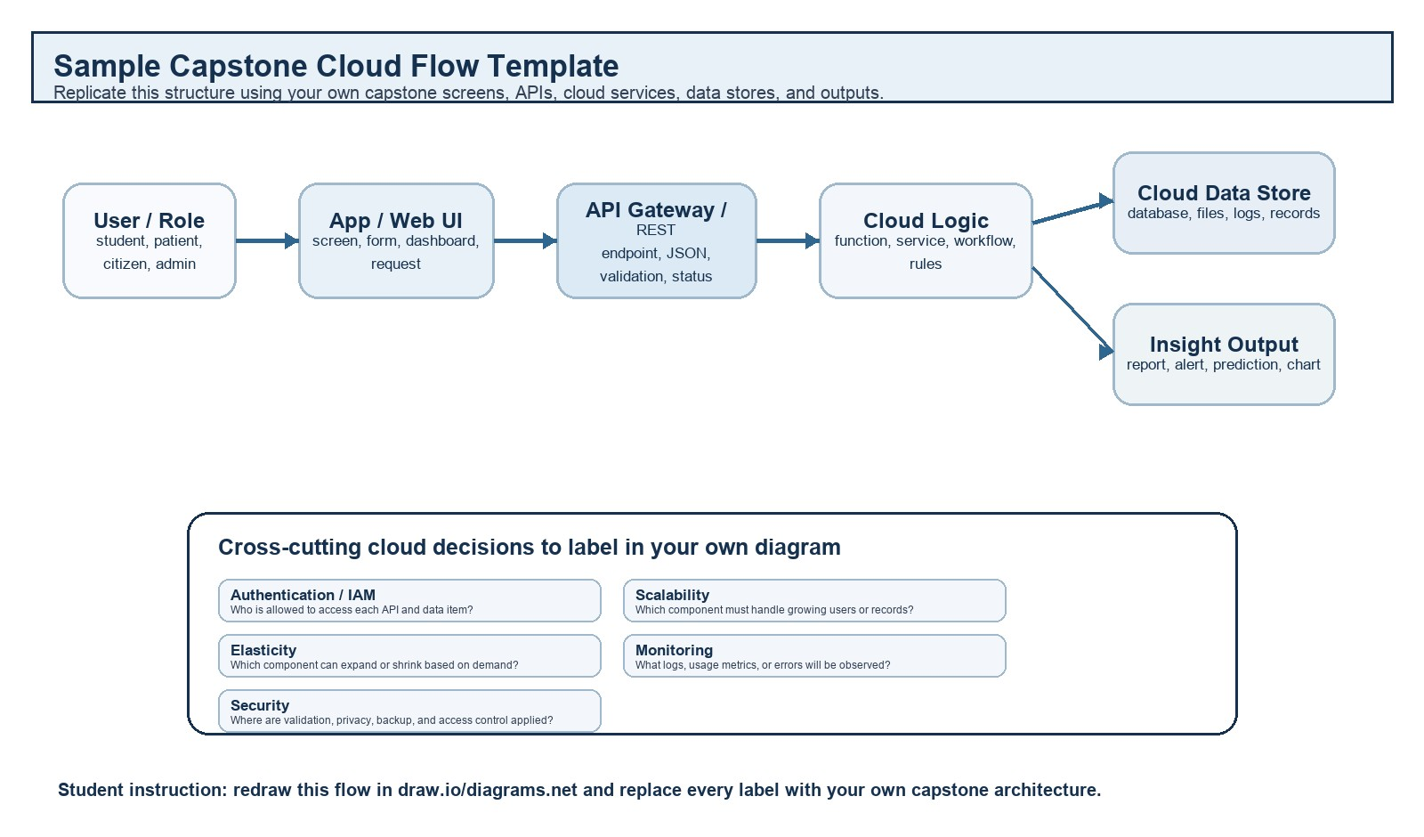
Student Drawing Requirement
Do not copy the sample as it is. Use it as a layout model, then create your own capstone-specific flow diagram with meaningful labels, arrows, data movement, API names, and cloud service choices.
Flow Component | Student Entry
User role and action
Frontend / app screen
API endpoint and method
Backend processing rule
Cloud database / storage operation
Response, alert, report, or dashboard output
Security, scalability, and elasticity labels added in diagram
Paste your redrawn capstone cloud-flow diagram here.
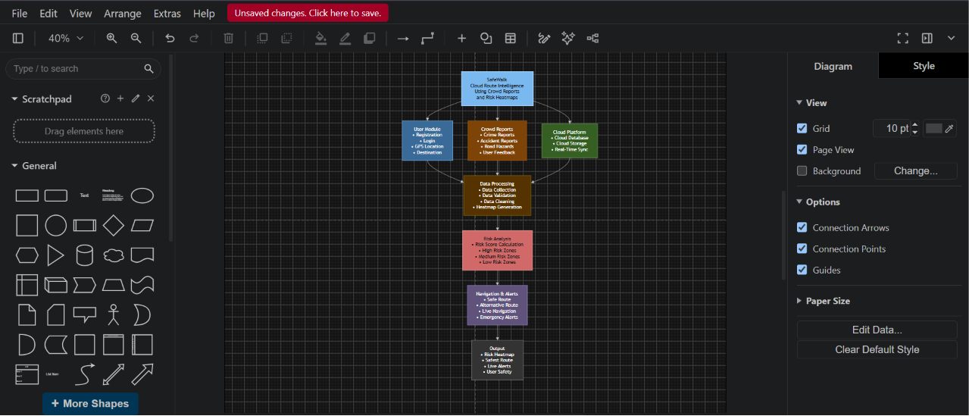

Brief explanation: explain one complete request-response path from user action to cloud response.
When a user submits an incident report through the SafeWalk mobile application, the report is sent to the cloud backend using a REST API. After validating the request, the backend stores the information in Firestore. Analytics services update the risk heatmap, and the route recommendation engine calculates the safest available path. The processed information is then returned to the user through the mobile application.

Task 4 - Individual Reflection
Answer the following from your own perspective. Avoid team-common wording.
1. What is the strongest cloud concept represented in your capstone project?
The strongest cloud concept in my project is cloud scalability because SafeWalk must support many users reporting incidents simultaneously while maintaining real-time performance.

2. Where will elasticity or scalability become important in your capstone product?
Elasticity is important during emergencies or large public events when thousands of users access the application simultaneously. Cloud resources automatically increase to maintain performance.

3. Which API or web-service idea is most relevant to your project and why?
REST APIs are the most important because they enable secure communication between the mobile application, cloud backend, Firebase database, and mapping services.

4. What did you personally understand better after preparing this concept map and matrix?
Preparing this concept map improved my understanding of cloud service models, virtualization, REST APIs, scalability, and how cloud computing enables real-time applications like SafeWalk.

Evaluation Rubric - 100 Marks
Criteria | Marks | Expected Standard
Concept identification | 20 | Major CO1 concepts are accurately identified: cloud fundamentals, characteristics, evolution, service models, deployment models, virtualization, web services,  SOAP/REST, APIs, elasticity, and scalability.
Relationship mapping | 20 | Links between concepts are accurate, meaningful, and labeled. The map should explain how concepts depend on, enable, consume, provide, scale, or control one another.
Hierarchy and organization | 15 | Concepts are arranged in a logical hierarchy with clear grouping, readable flow, and no disconnected keyword clusters.
Technical relevance | 15 | The map strongly reflects cloud course content and avoids decorative or generic non-technical content.
Service model matrix | 15 | IaaS, PaaS, SaaS, and XaaS are compared with provider responsibility, user responsibility, examples, capstone usage, and risks or limitations.
Capstone alignment and individual reflection | 10 | The student's own capstone interpretation is visible in the concept map, flow mapping, justification, and reflection. Team-common answers are avoided.
Visual clarity and digital evidence | 5 | Diagram is neat, readable, exported properly, and supported with GitHub evidence including source and exported files.

Faculty Evaluation Record
Evaluator Name |  | Marks Awarded
Observation |  | Signature

